EVA Builder Script Poly

|  |  |
| --- | --- |
| Build Version | 1.1 |
| Build Date | 28th June 2022 |
| Author | Jordan Prescott |

# Prerequisites

1. Services must be authorised and assigned to group:
   1. Trunk Group
   2. Hunt Group
2. Service packs must be authorised for use in the group:
   1. EVA-AGENT-{Num of Agents}
   2. EVA-AGENTB-{Num of Bursting}
   3. SIP-DID
3. The Group Default domain must be set correctly.
4. The Group maximum user limit must be set high enough to build the users.
5. The Group Maximum Extension Length should be set to the correct extension length.

# Running the Script

Call the script into the python application from the command line and follow the prompts.

*Below is an example of the legacy eva builder but the concept is the same.*

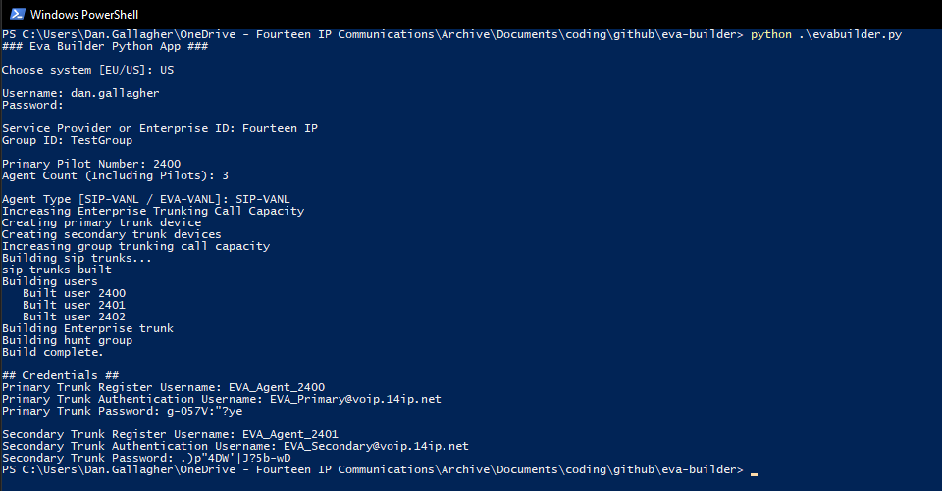

# Manual Additions

Some things cannot be set with the script, so these need to be manually configured:

* Hunt Groups
  + Manually set the weightings
  + Set the phone number
* Overflow Trunk Groups
  + Set the overflow destination with the trunk group call forward always.

# Release Additions

To see the latest release notes and features added please look under releases to the right hand side in the below at <https://github.com/Jordan-Prescott/eva-builder-Poly>